

Concordia Institute for Information System Engineering (CIISE)

## Concordia University

**INSE 6150 – Security Methodology Evaluations**

## Assignment -1:

Submitted to:

**Professor Jeremy Clark**

Submitted By:

**Nithish Reddy Yalaka - 40164619**

## **Systems**:

## Vaccine Passports Recently, Quebec has introduced a system for residents to prove they have been adequately vaccinated against COVID19. Consider a few possible designs for a vaccine passport system used by a customer at a restaurant.

## **The Quebec System**: the Quebec government issues a digital message with: (1) a name, (2) a birthdate, and (3) indication of a fully vaccinated status. This message is signed with the government of Quebec’s public key. The signed message is encoded into a QR code which can be displayed on paper or in a smartphone app by the customer, along with a piece of photo ID. The restaurant checks with the assistance of an smartphone app: (1) the photo on the ID matches the person, (2) the name/birthdate on the ID matches the QR code, (3) the QR code indicates the vaccination status, and (4) the QR code contains a digital signature by the Quebec government.

## **A Physical Card System:** the Quebec government will take a photograph and issue a physical card (like a driver’s license or health card) with a name, photo, and vaccination status on it. It will be mailed to people vaccinated in Quebec. A customer displays this card to the restaurant. The restaurant checks (1) the photo on the card matches the person, and (2) the card displays the vaccination status.

## **An Online System:** the Quebec government gives each vaccinated person a unique identity number encoded into a QR code which can be displayed on paper or in a smartphone app by the customer. The restaurant scans the code from the back of the card with a smartphone app from the Quebec government that queries a server run by the Quebec government using HTTPS. The server responds with the customer’s name, ID, address, photograph, and confirmation of their vaccination status. The restaurant checks with the assistance of an smartphone app: (1) the photo matches the person, and (2) the app displays the vaccination status.

## (Question 1)

**STRIDE**

STRIDE is a Dive in and Threat Model and stands for Spoofing, Tampering, Repudiation, Information Disclosure, Denial of Service, and Elevation of Privilege.

It is also known as Model of Threats used to help reason and find threats to a system.

**Spoofing:**

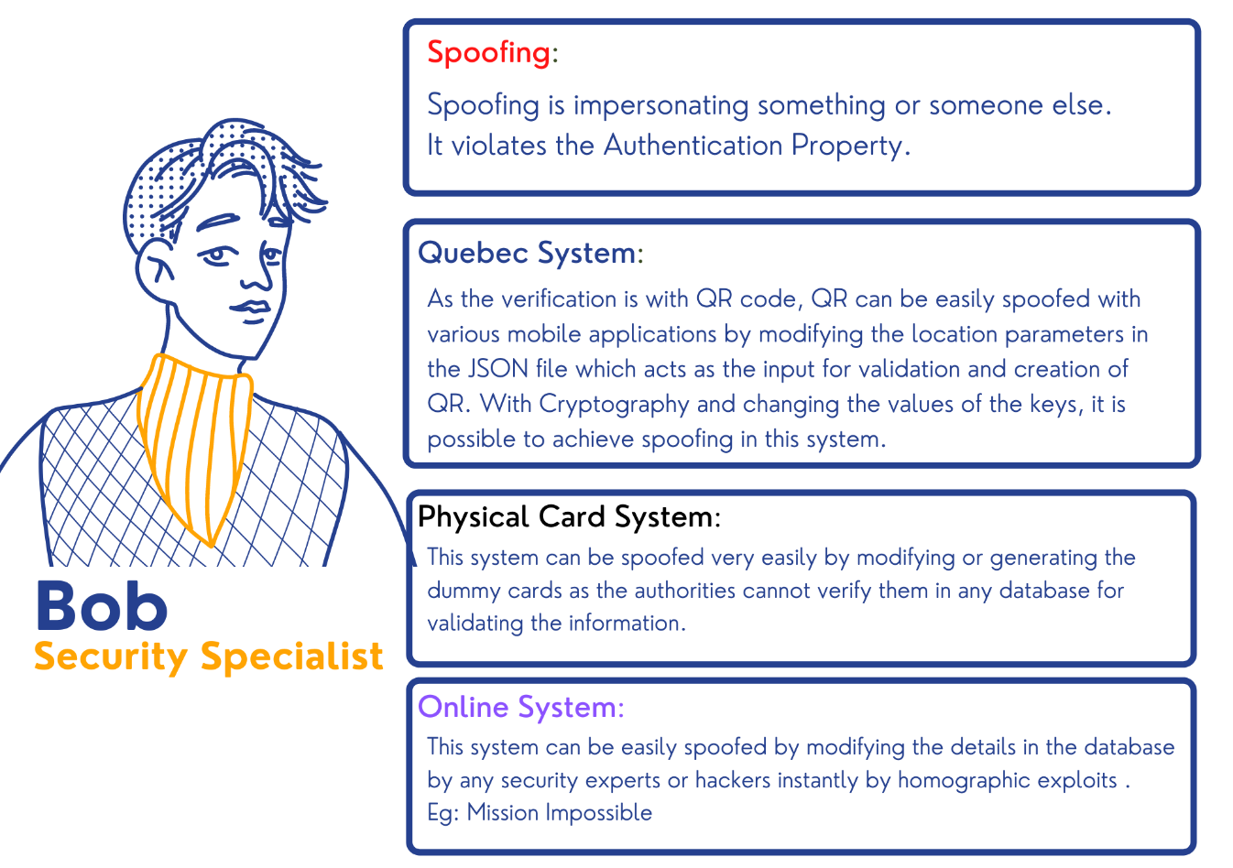

**Tampering**:

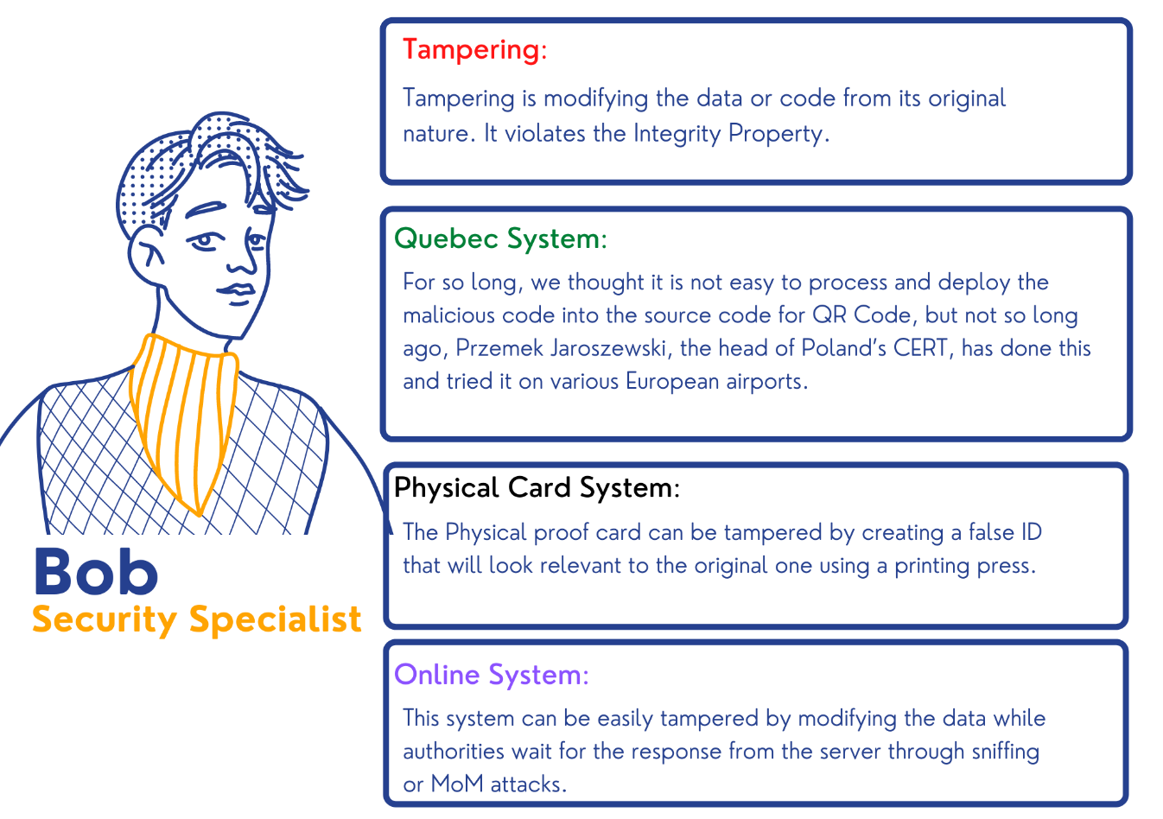

**Repudiation**:

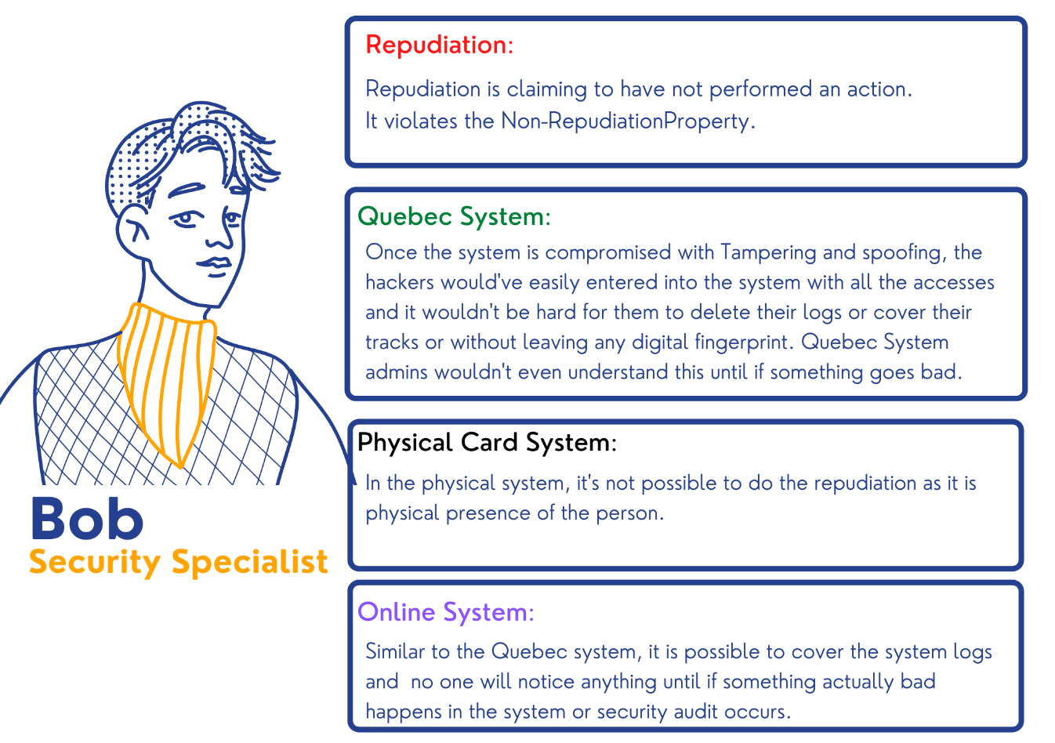

**Information Disclosure:**

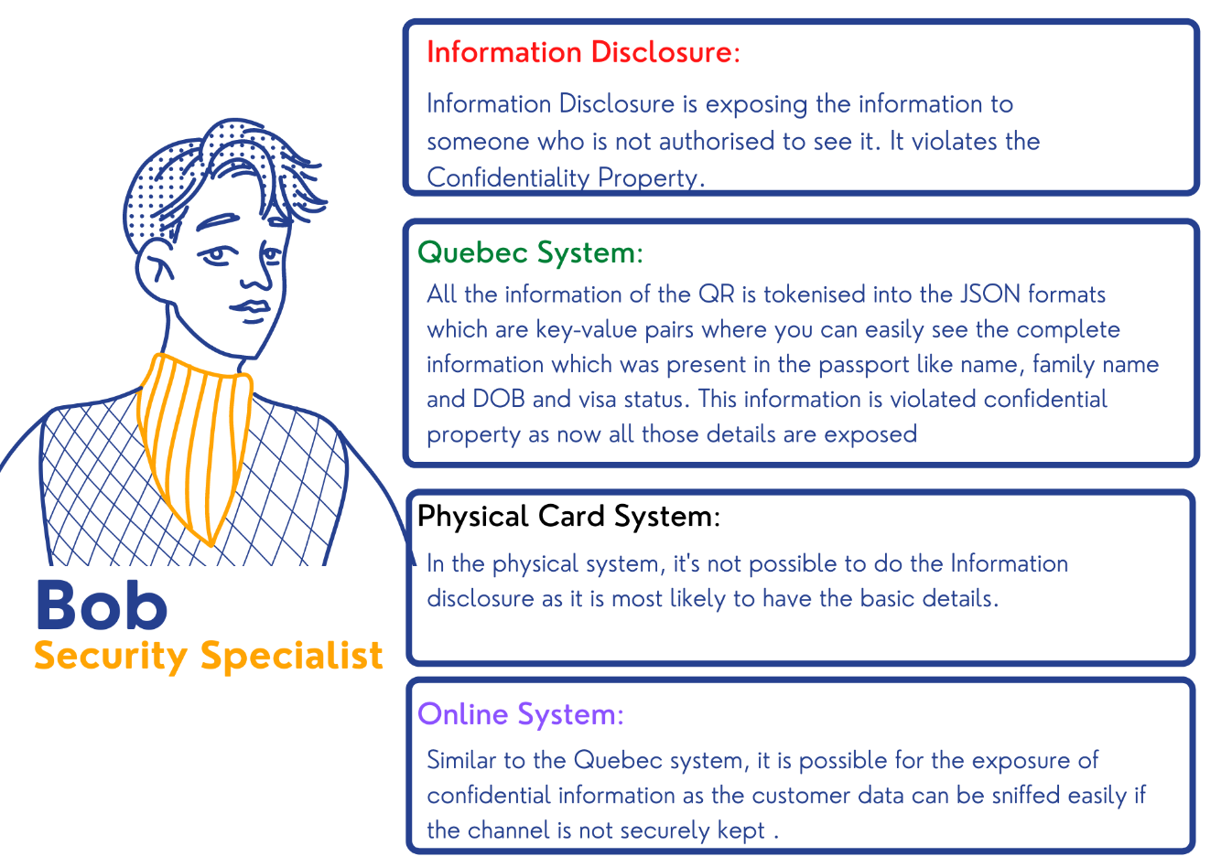

**Denial of Service:**

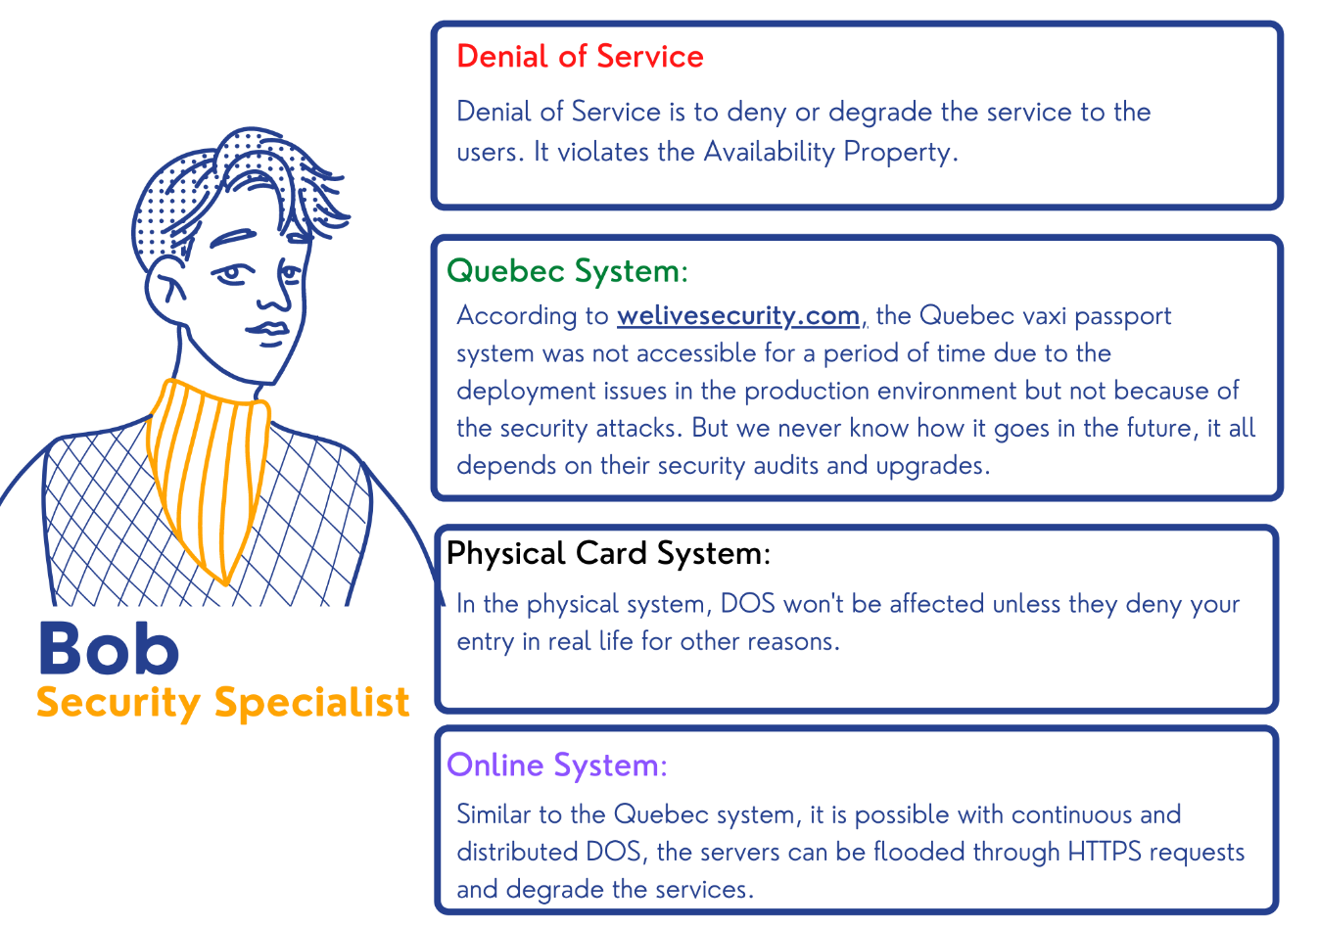

**Elevation of Privilege:**

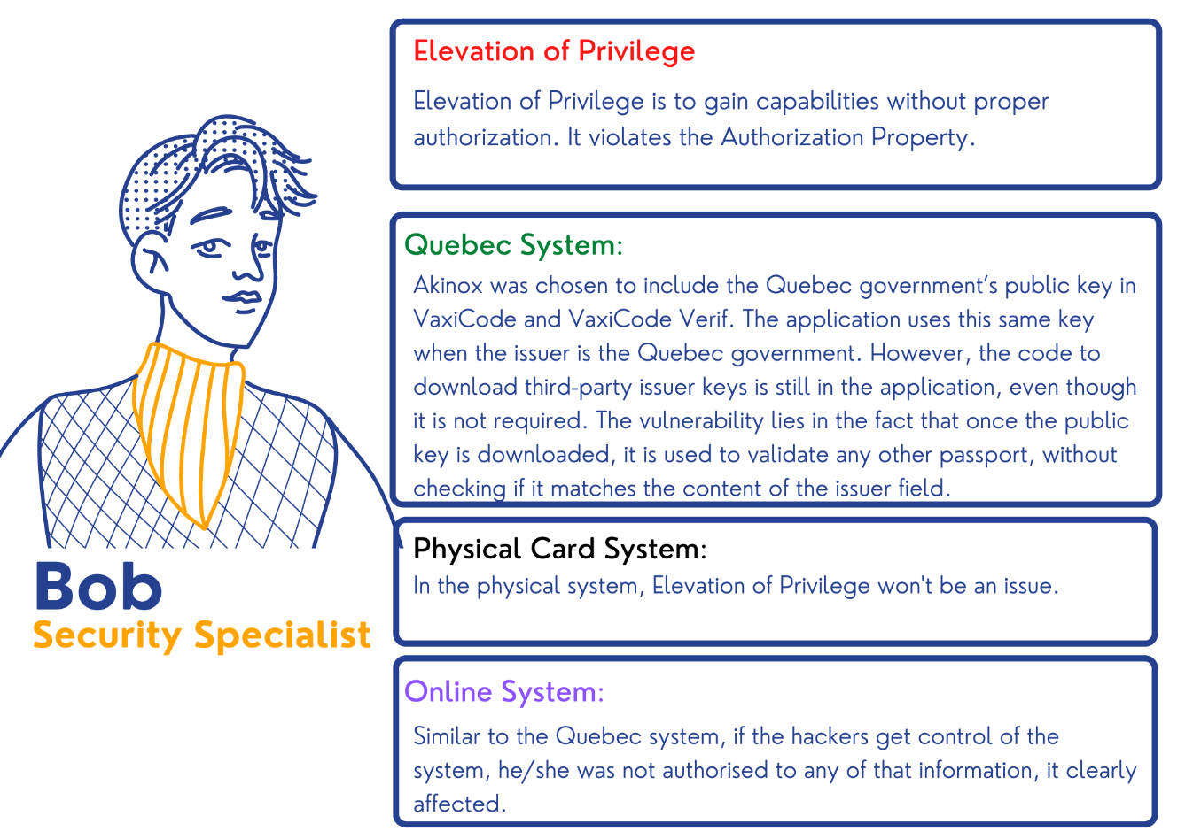

## (Question 2)

**Security Evaluation Criteria:**

It is the comparison between the alternatives. Here there are no solutions, only the tradeoffs.

The deliverable is a simple chart , coming up with the criteria is harder than it seems.

Usually, there is more to security than the actual security(security, usability, deploy ability).

UDS Framework.

**6 Security Evaluation Criteria:**

**S1:Resilient to Physical Theft**

**S2: Resilient to Spoofing**

**S3: Resilient to Phishing:**

**S4: Resilient to Elevation of Privilege**

**S5: Resilient to Tampering**

**S6: Resilient to Identify the Threats**

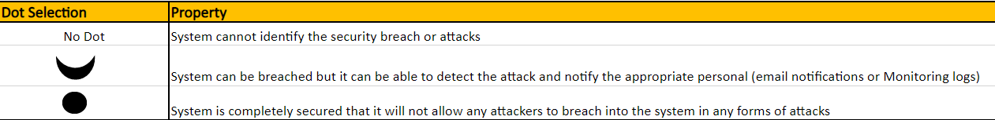

## (Question 3)

**6 Usability Evaluation Criteria:**

**U1: Error Free**

**U2: Efficient to Access**

**U3: No Password Requirement**

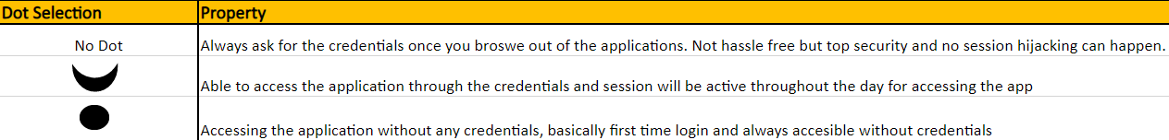

**U4: Ease of Use for Users**

**U5: Nothing to Carry**

**U6: No Dependency on the Internet**

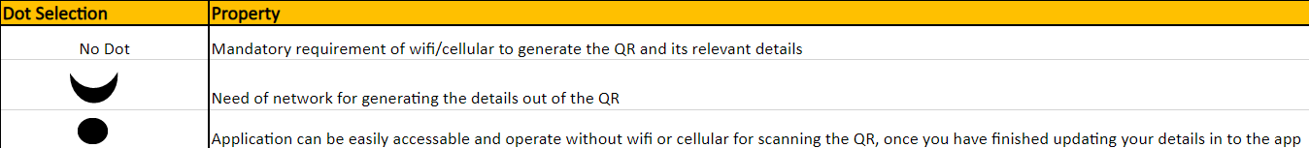

**6 Deployability Evaluation Criteria:**

**D1: Negligible Cost/Cost Effectiveness**

**D2: Ease of Application Download**

**D3: Cross-Platform Support**

**D4: Continuous Product Improvements**

**D5: Application Control and Authority**

**D6: Customer Support Availability**

## (Question 4)

**Evaluation of Quebec System:**

**If the Image is not properly Visible, please find the link for the above sheet below:**

[**https://liveconcordia-my.sharepoint.com/:x:/g/personal/n_yalaka_live_concordia_ca/Eew-py-aIfhBlPuS1s873-cBPs0wnXnrZVBJVQzQxrik4A?e=qul2Me**](https://liveconcordia-my.sharepoint.com/:x:/g/personal/n_yalaka_live_concordia_ca/Eew-py-aIfhBlPuS1s873-cBPs0wnXnrZVBJVQzQxrik4A?e=qul2Me)